**MINI PROJECT 1**

1. **Create a schema based on the given dataset**

Create table AgentLogingReport

(

sr_no int,

Agent string,

Date string,

Login string,

Logout string,

Duration string

)

row format delimited

fields terminated by ','

tblproperties ("skip.header.line.count" = "1");

Create table AgentPerformance

(

sr_no int,

Date string,

Agent_Name string,

Total_charts int,

Avg_Response_Time string,

Avg_Resolution_Time string,

Avg_Rating float,

Total_Feedback int

)

row format delimited

fields terminated by ','

tblproperties ("skip.header.line.count" = "1");

1. **Dump the data inside the hdfs in the given schema location.**

load data inpath '/tmp/a_1/AgentLogingReport.csv' into table AgentLogingReport ;

load data inpath '/tmp/a_1/AgentPerformance.csv' into table AgentPerformance;

1. **List of all agents' names.**

select distinct(agent_name) from AgentPerformance ;

1. **Find out agent average rating.**

select agent_name , avg(avg_rating) from AgentPerformance group by agent_name;

1. **Total working days for each agents**

select count(date) , agent from AgentLogingReport

group by agent;

1. **Total query that each agent have taken**

select agent_name , sum(total_chats) from AgentPerformance group by agent_name;

1. **Total Feedback that each agent have received**

select agent_name ,sum(total_feedback) from AgentPerformance group by agent_name;

1. **Agent name who have average rating between 3.5 to 4**

select agent_name , avg(avg_rating) from agentperformance where avg_rating between 3.5 and 4 group by agent_name ;

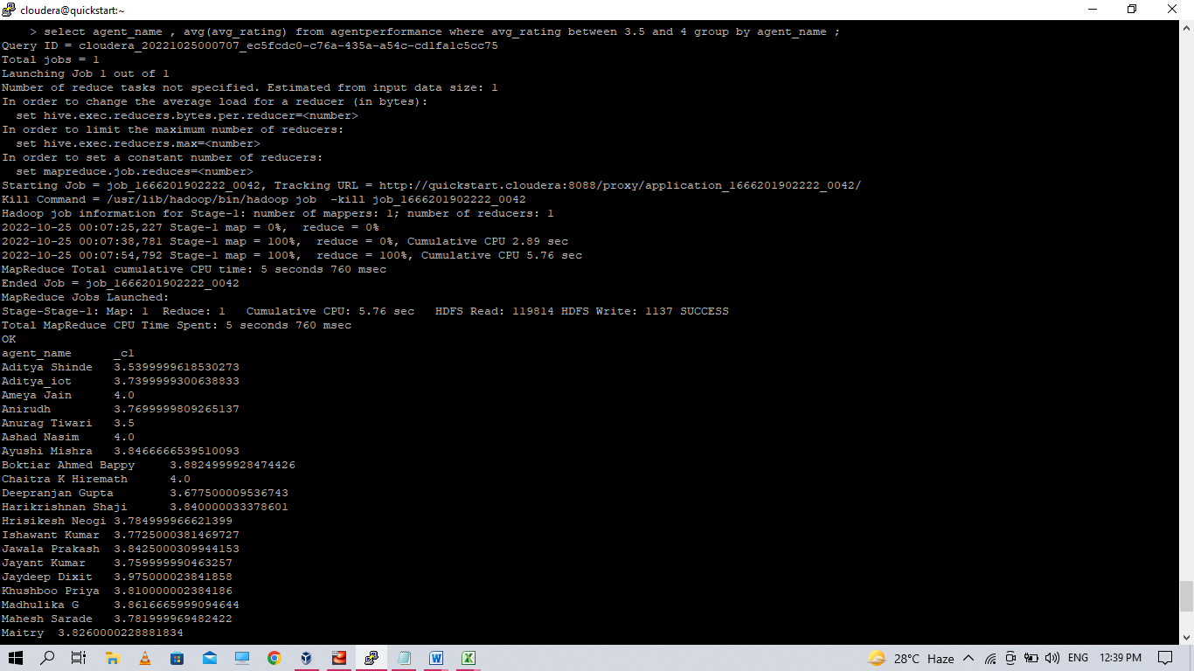

1. **Agent name who have rating less than 3.5**

select agent_name , avg_rating from agentperformance where avg_rating < 3.5 ;

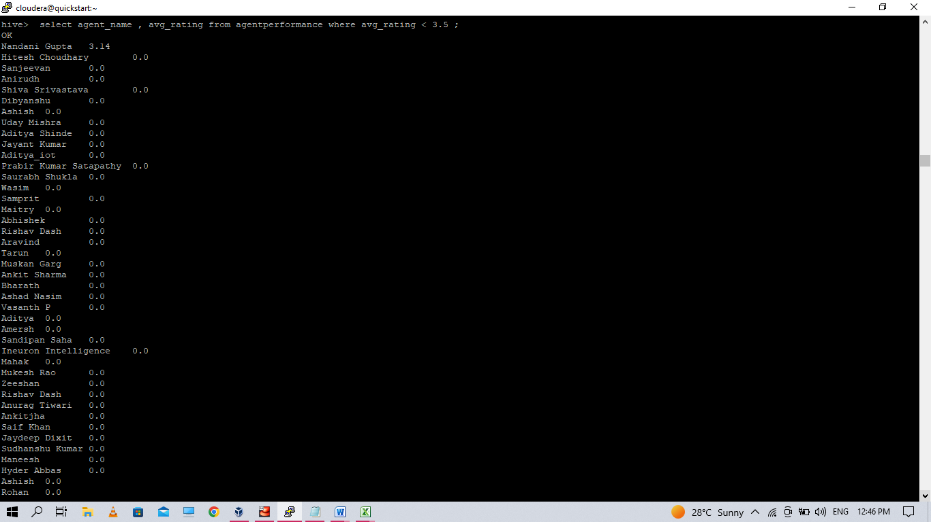

1. **Agent name who have rating more than 4.5**

select agent_name , avg_rating from agentperformance where avg_rating > 4.5 limit 15 ;

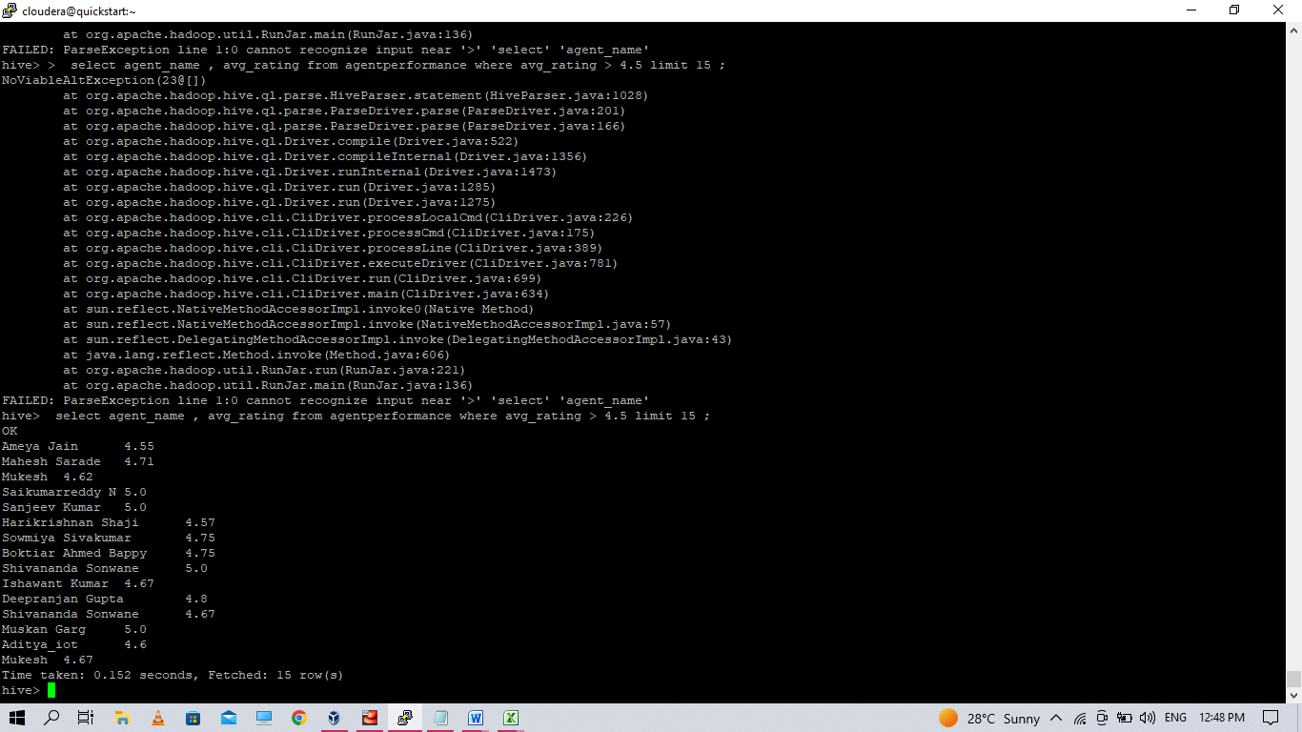

1. **How many feedback agents have received more than 4.5 average**

select agent_name , sum(total_feedback) from agentperformance where avg_rating > 4.5 group by agent_name ;

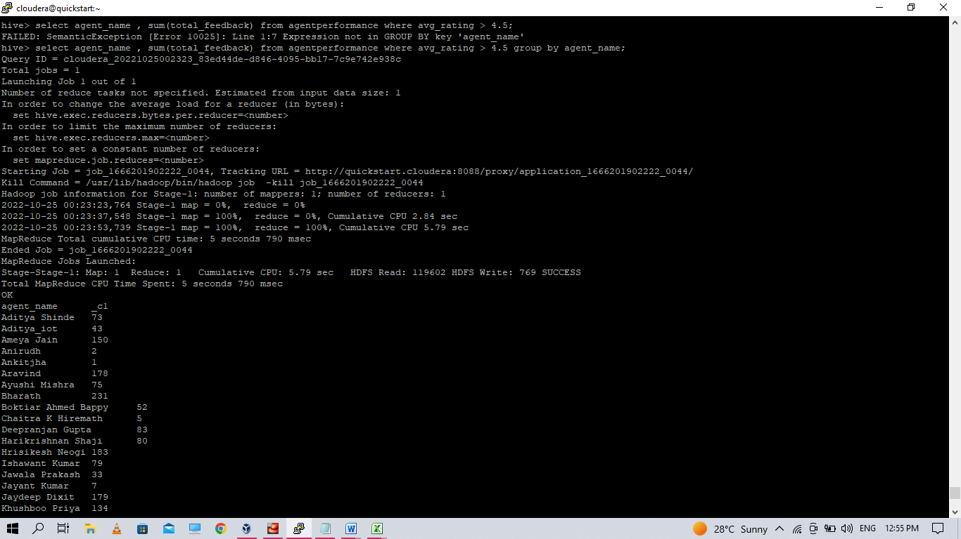

1. **average weekly response time for each agent**

> select agent_name,avg(col1[0]*3600+col1[1]*60+substr(col1[2],1,2))/360 from (select agent_name,split(Avg_Response_Time,':') as col1 from AgentPerformance )s group by agent_name;

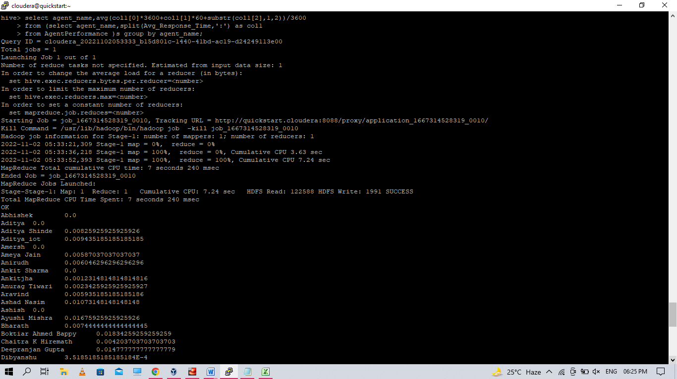

1. **average weekly resolution time for each agents**

select agent_name,avg(col1[0]*3600+col1[1]*60+substr(col1[2],1,2))/3600 from(select agent_name,split(Avg_Resolution_Time,':') as col1 from AgentPerformance )s group by agent_name;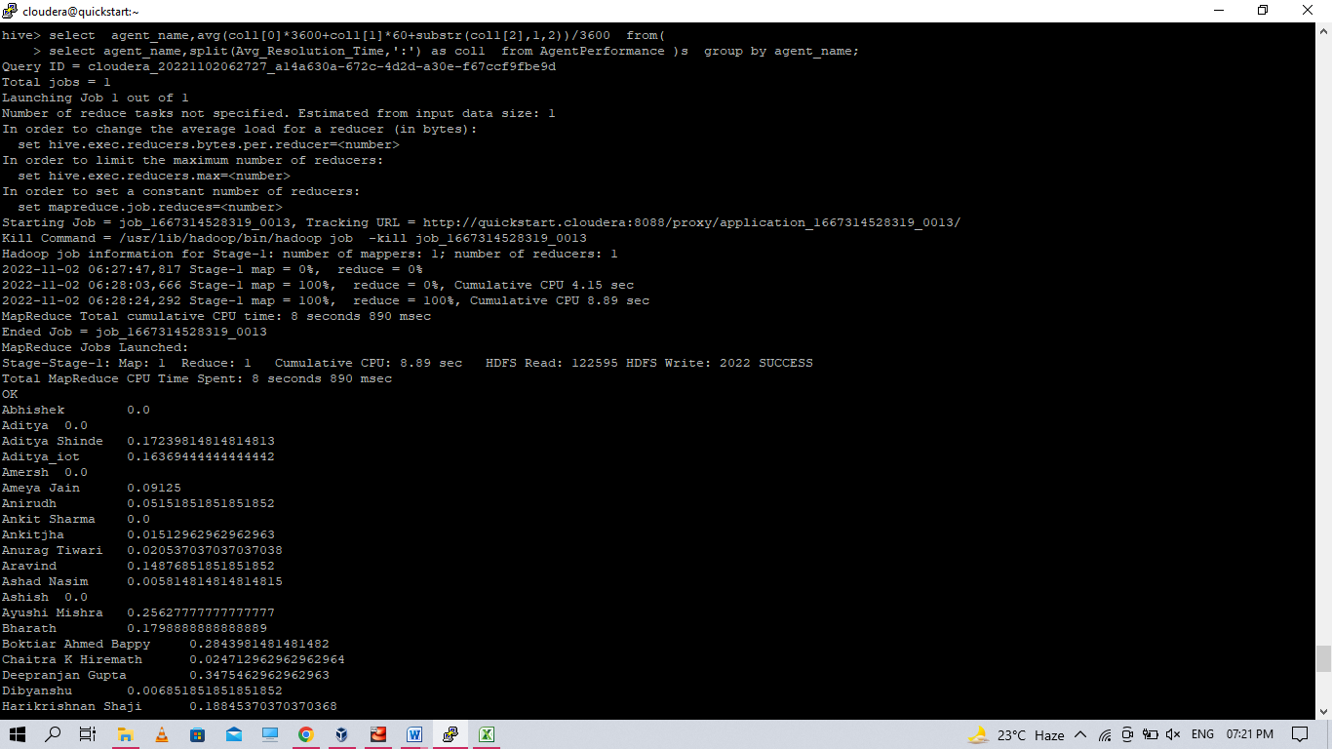

1. **Find the number of chat on which they have received a feedback**

select agent_name , sum(total_chats) from agentperformance where total_feedback > 0 group by agent_name ; 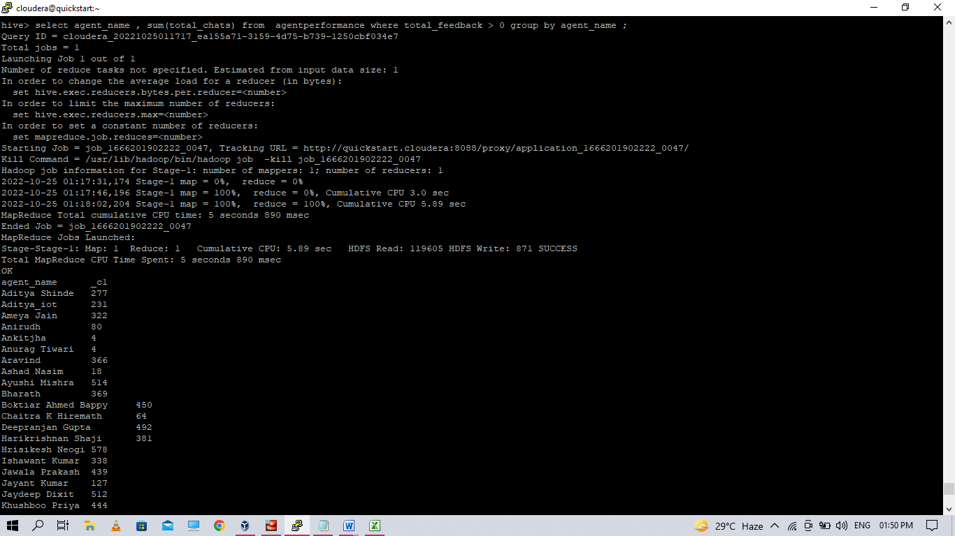

1. **Total contribution hour for each and every agents weekly basis**

select s.agent,sum(col1[0]*3600+col1[1]*60+col1[2])/3600 timeInHour,s.weekly from (select agent,split(duration,':') as col1 ,weekofyear(Date) as weekly from AgentLogingReport )s group by s.agent,s.weekly limit 2; 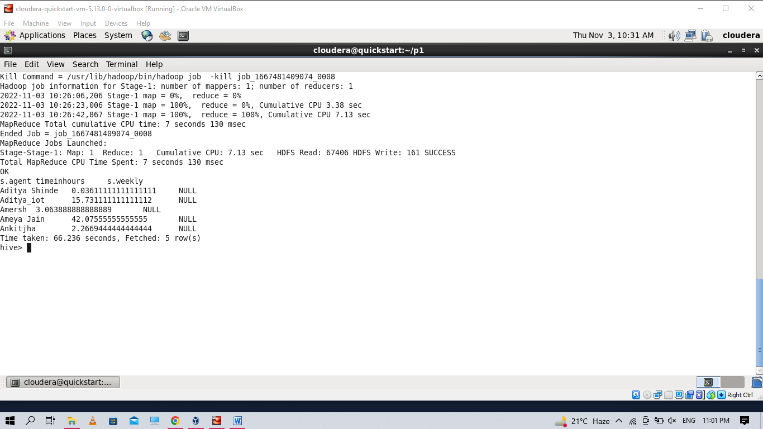

1. **Perform inner join, left join and right join based on the agent column and after joining the table export that data into your local system.**

**INNER JOIN**

Select agent, total_chats, total_feedback from agentlogingreport inner join agentperformance on (agentlogingreport.agent = agentperformance.agent_name) limit 5;

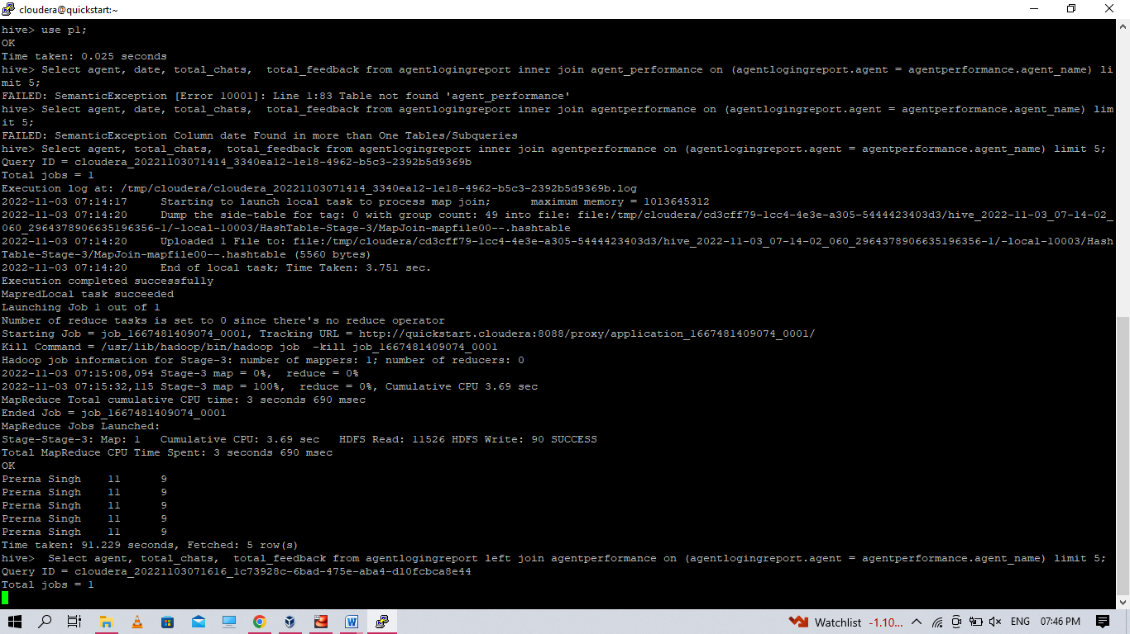

**LEFT JOIN**

Select agent, total_chats, total_feedback from agentlogingreport left join agentperformance on (agentlogingreport.agent = agentperformance.agent_name) limit 5

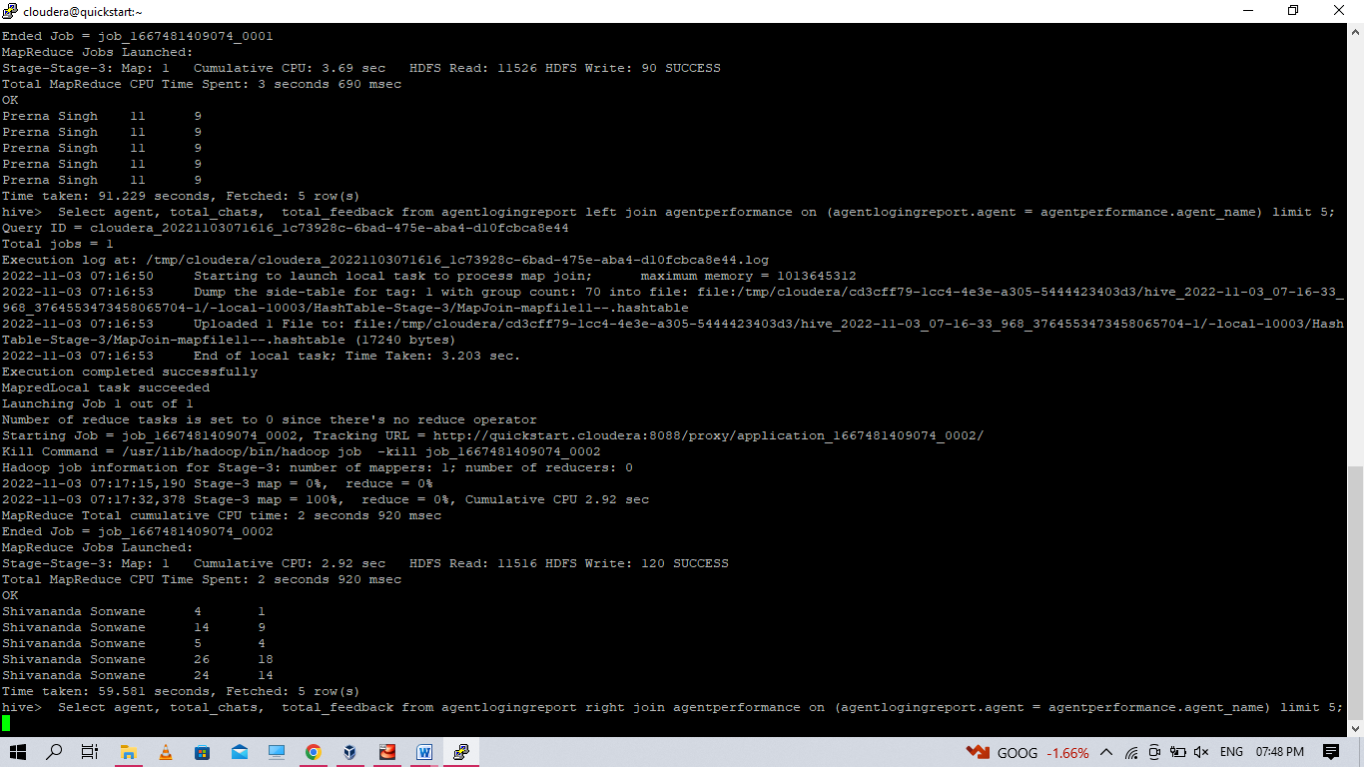

**RIGHT JOIN**

Select agent, total_chats, total_feedback from agentlogingreport right join agentperformance on (agentlogingreport.agent = agentperformance.agent_name) limit 5;

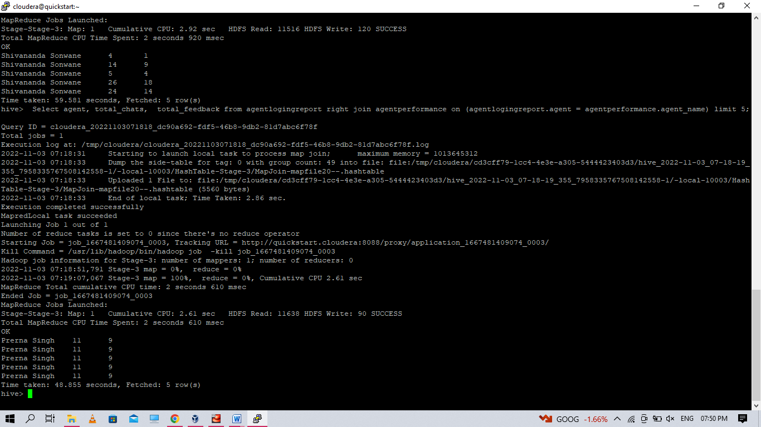

**EXPORT THE OUPUT DATA INTO LOCAL SYSTEM**

**INNER JOIN**

$ hive -e'Select agent, total_chats, total_feedback from p1.agentlogingreport inner join p1.agentperformance on (agentlogingreport.agent = agentperformance.agent_name) limit 5' >/home/cloudera/p1/inner_join.csv

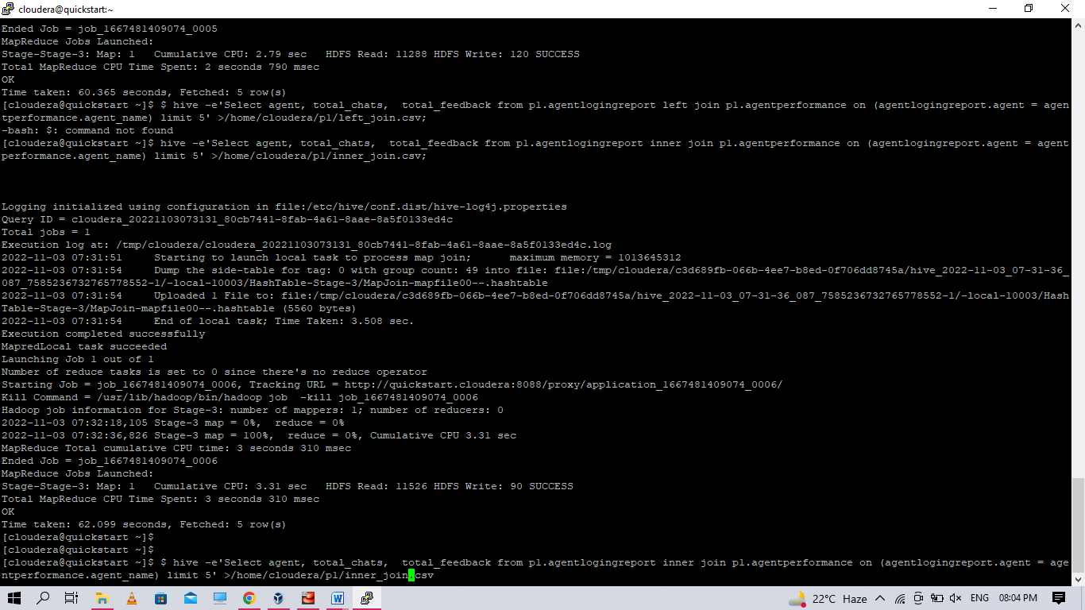

**LEFT JOIN**

$ hive -e'Select agent, total_chats, total_feedback from p1.agentlogingreport left join p1.agentperformance on (agentlogingreport.agent = agentperformance.agent_name) limit 5' >/home/cloudera/p1/left_join.csv;

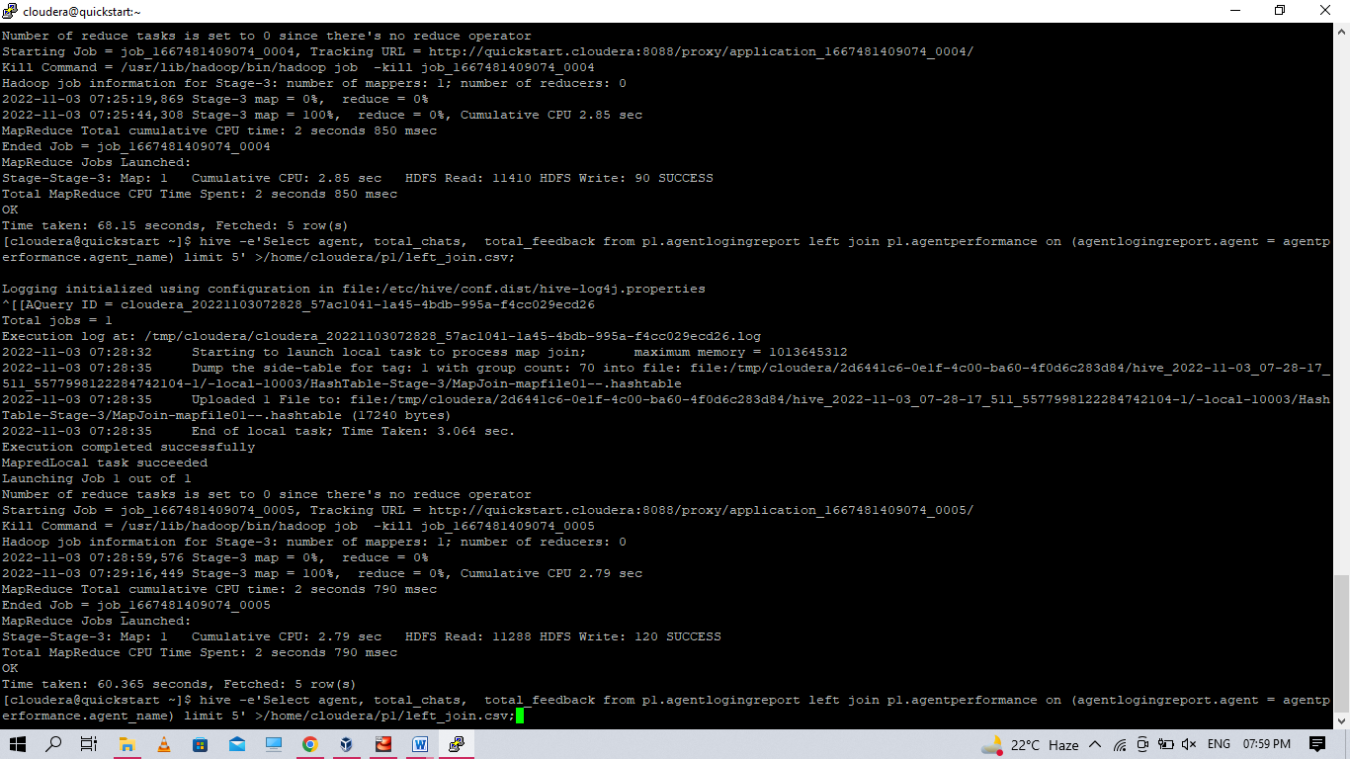

**RIGHT JOIN**

hive -e'Select agent, total_chats, total_feedback from p1.agentlogingreport right join p1.agentperformance on (agentlogingreport.agent = agentperformance.agent_name) limit 5' >/home/cloudera/p1/right_join.csv;

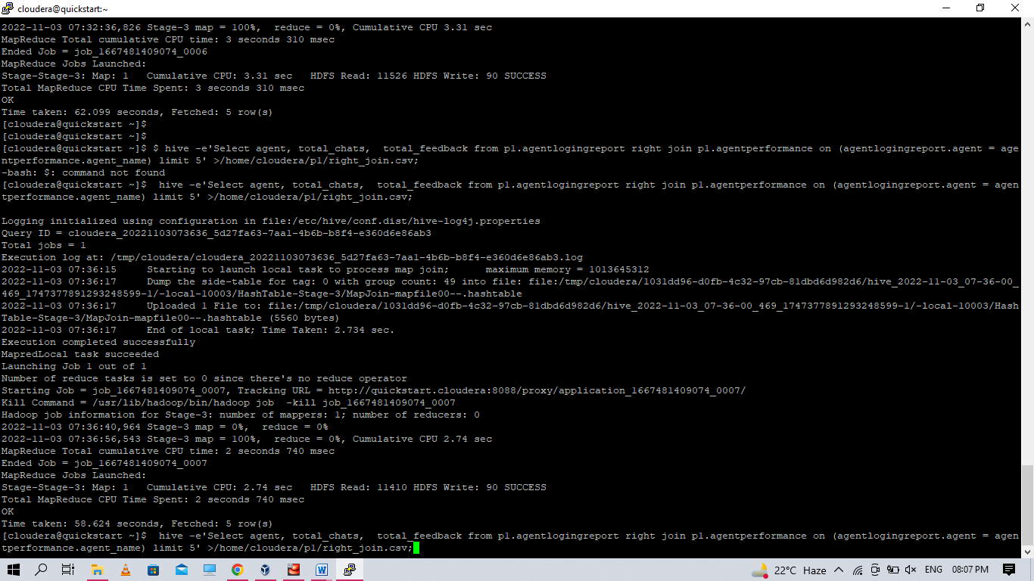

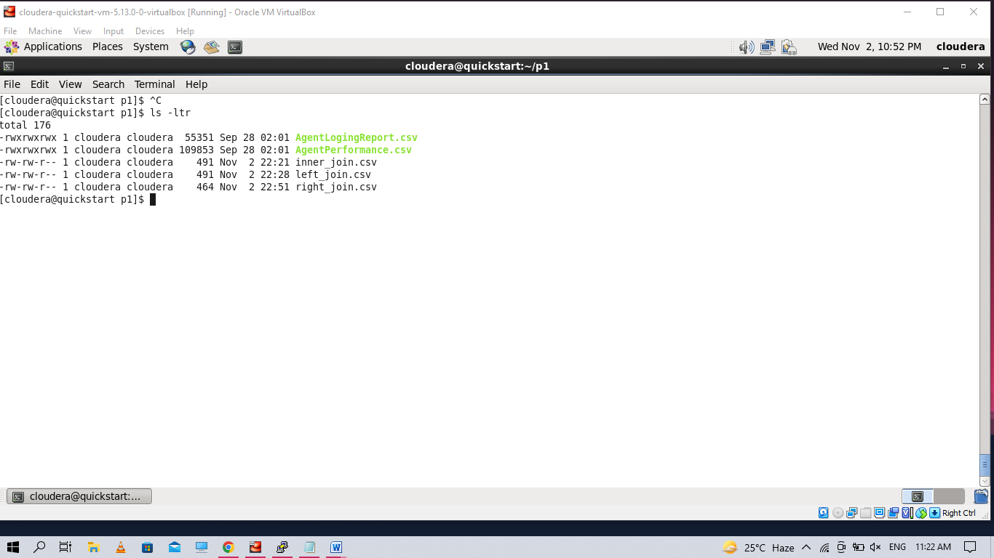

1. **Perform partitioning on top of the agent column and then on top of that perform bucketing for each partitioning.**

hive> set hive.exec.dynamic.partition=true;

hive> set hive.exec.dynamic.partition.mode=nonstrict;

hive> set hive.enforce.bucketing=true;

Create table AgentLogingReport_partition

(

sr_no int,

Date date,

Login string,

Logout string,

Duration string

)partitioned by (Agent string)

CLUSTERED BY (Date) sorted by (Date) INTO 4 BUCKETS

ROW FORMAT DELIMITED

FIELDS TERMINATED BY ',';

insert into table AgentLogingReport_partition partition(Agent) select sr_no,Date,Login,Logout,Duration,Agent from AgentLogingReport;

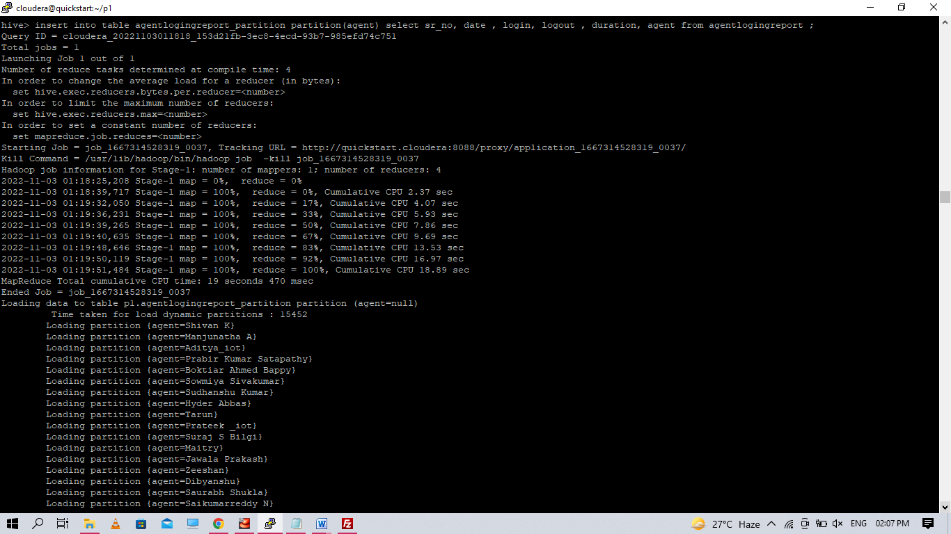

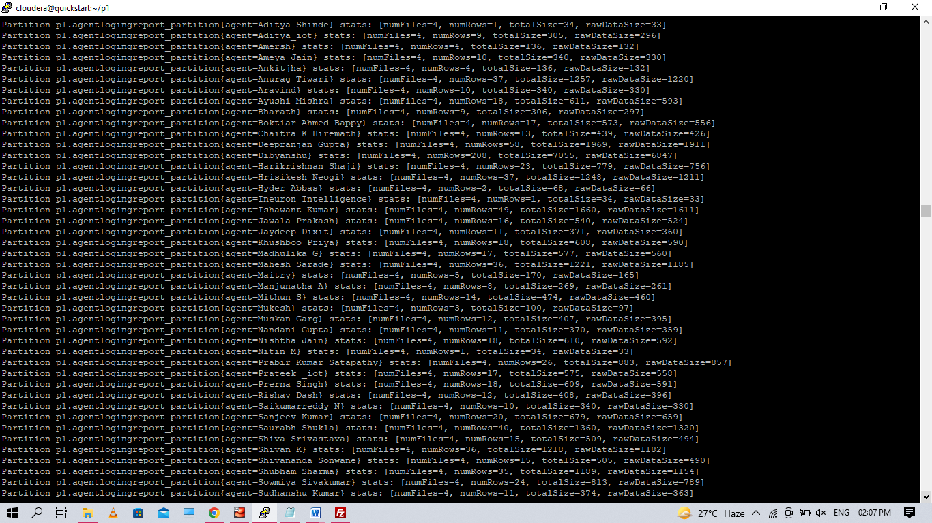

create table AgentPerformance_partition

(

sr_no int,

Date date,

Total_chats string,

Avg_Response_Time string,

Avg_Resolution_Time string,

Avg_Rating float,

Total_Feedback int

)partitioned by (Agent_name string)

CLUSTERED BY (Date) sorted by (Date) INTO 8 BUCKETS

ROW FORMAT DELIMITED

FIELDS TERMINATED BY ',';

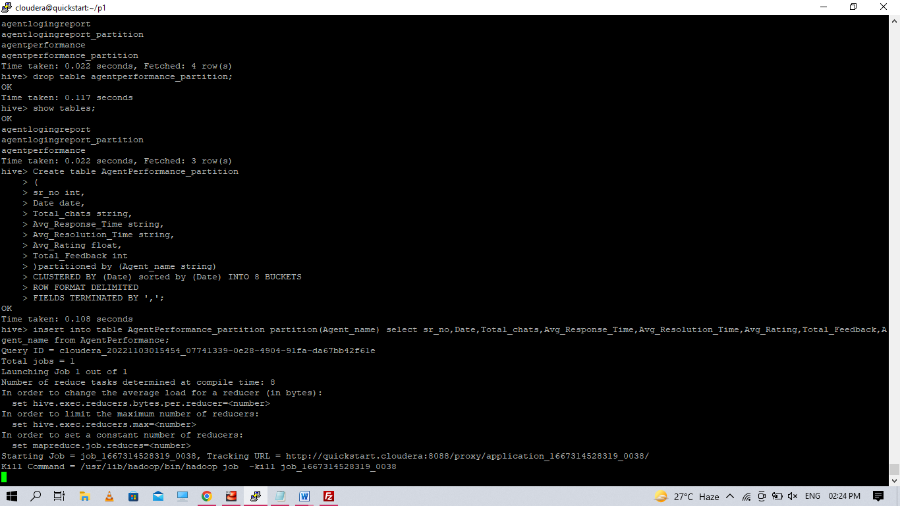

Hive> insert into table AgentPerformance_partition partition(Agent_name) select sr_no,Date,Total_chats,Avg_Response_Time,Avg_Resolution_Time,Avg_Rating,Total_Feedback,Agent_name from AgentPerformance;

